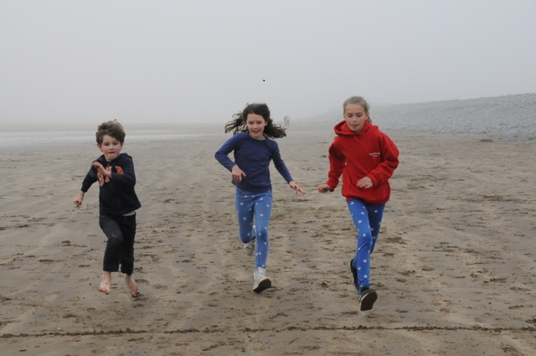

Becoming a volunteer with children, young people or vulnerable adults

Issue 4: April 2020

INTRODUCTION

Thank you for applying to join the children, young people or vulnerable adults volunteer teams at St Peter and St Paul’s Church Buckingham – we are delighted that you want to be involved with this work.

Working with children, young people and vulnerable adults is an important part of the life of the church. We take the appointment and support of our volunteers very seriously. We want to make sure that we make good volunteer appointments, and therefore need to know something about you before you can take up your role. There are also some legal requirements that have to be met as part of the appointment process. Please be assured that all information supplied by you will be held in strictest confidence, and seen only by the individuals appointed by the Parochial Church Council (PCC) to manage the process. If you have any questions, please do talk to one of the key contacts listed overleaf.

All volunteer appointments are approved by the PCC. This leaflet explains how the appointment process works and sets out the information that is required.

APPLYING TO BE A VOLUNTEER

Stage 1 – Completion of the Volunteer Application Form and Confidential Declaration Form
The forms can be downloaded from the church website, or your group leader can provide a soft or hard copy. You are asked to provide basic information about yourself, including any relevant training or experience that you may have had. Previous experience is not essential – we are very happy to support you in developing your skills.

The Confidential Declaration Form asks you to declare any past criminal convictions or issues in relation to the protection of children or vulnerable adults. Please answer this declaration fully. If you are answering ‘yes’ to any of these questions, please contact the Safeguarding Officer to discuss the implications. Depending on the circumstances, it will not necessarily bar you from being appointed.

References: In the Application Form, we ask you to give the names of two people who we can approach to provide a reference. Your referees should be people who know you well and should not be relatives, members of staff at this church, or the person you will be reporting to in your volunteer role. Examples might be a former vicar or youth leader, a friend within the church or elsewhere, or a current or a past work colleague. We do follow up your references, so please make sure that the contact details you provide are correct, and do let your referees know that we will be contacting them.

Please complete and return the application form and confidential declaration form to the Safeguarding Team within 2 weeks of receiving it. (You can either email it to Safeguarding@bpchurch.uk or hand it in to the Church Office)

Stage 2 - Disclosure and Barring Service (DBS) Check

We are legally required to obtain Disclosure and Barring Service (DBS) clearance for most volunteer applications. The DBS is a government body that checks that an applicant does not have a criminal record. When we have received completed references, we will contact you to begin the DBS check, which will include checking your ID.

Stage 3 – Sign-Off Meeting

Finally, we will arrange a short meeting for you with one of the Safeguarding Officers. The purpose of this meeting is to make sure that you are comfortable with the role you have been asked to take on, to answer any questions that you may have, and to discuss any training or support that may be appropriate.

AFTER YOUR APPOINTMENT – SUPERVISION AND TRAINING

You will be provided with a clear volunteer role description and you will have a group leader whom you can approach for support and guidance. All volunteers must complete our Foundation Safeguarding Training module to ensure that they are up to date on current best practice for supporting and safeguarding children and vulnerable adults. You will receive an invitation to this training shortly after your appointment. The module must be repeated every 3 years.

Summary of appointment process for volunteers

Complete Application Form and Confidential declaration and send to Safeguarding Team
Safeguarding Team contacts you to check ID and initiate DBS clearance process

PCC approves the appointment
Safeguarding team contacts you to arrange Sign-Off meeting

Begin your volunteer role, supported by your Group Leader
Discuss proposed role with member of the Staff Team

KEY CONTACTS

Jane Wardale and Denise Evans act as the Parish Safeguarding Officers, and also manage the recruitment and DBS processes for volunteers. Please contact them for any questions or concerns relating to volunteer recruitment, or safeguarding issues.
They can be contacted at Safeguarding@bpchurch.uk

Further information and all key documents and forms are available on the Safeguarding page of the church website
https://www.buckinghamparishchurch.org.uk/Groups/286523/Safeguarding.aspx

